

**DENTIST BOOKING SYSTEM**

**Software Requirement Specification**

– Tp Ho Chi Minh, August 2019 –

**Table of Contents**

I. Overview 3

1. Introduction 3

2. System Functions 4

3. Common Requirements 7

II. Functional Requirements **.**

1. Feature Name 1 **.**

a. Function Name 1 **.**

b. Function Name 2 **.**

2. Feature Name 2 **.**

# I. Overview

## 1. Introduction

The Dentist Booking System is a software system that automates the process of dentist booking service. It will help them to manage the customers booking easily and also to keep the customers data more safe. It will also help staff to keep in track their customer’s online booking request as well as easily to reply feedback to the customers.

The project is specifically designed for the use of customers and employees. The product will work as a complete user interface for a dentist service booking system. It will be available 24/7 and intends to offer an efficient, informative, and user-friendly website for customers to book reservations for their teeth issues.  Customers will be able to easily make reservations for a vast range of services at very suitable rates.

Customers can register an account with their personal phone number or gmail (limit 1 gmail (phone number) / 1 account). The customer account is used to schedule the service, the system will record the request and the booking information will be displayed to the customer. The system allows direct communication with employees and can send feedback and service evaluation through the system. Customers can view appointment information by personal account, and can change the schedule depending on the needs of each customer.

Through the system, the staff will receive the customer's request and can accept or refuse the service (due to a number of reasons). Employees can view each customer's booking schedule, customer information, and employees are responsible for answering customer messages through the system's chat box.

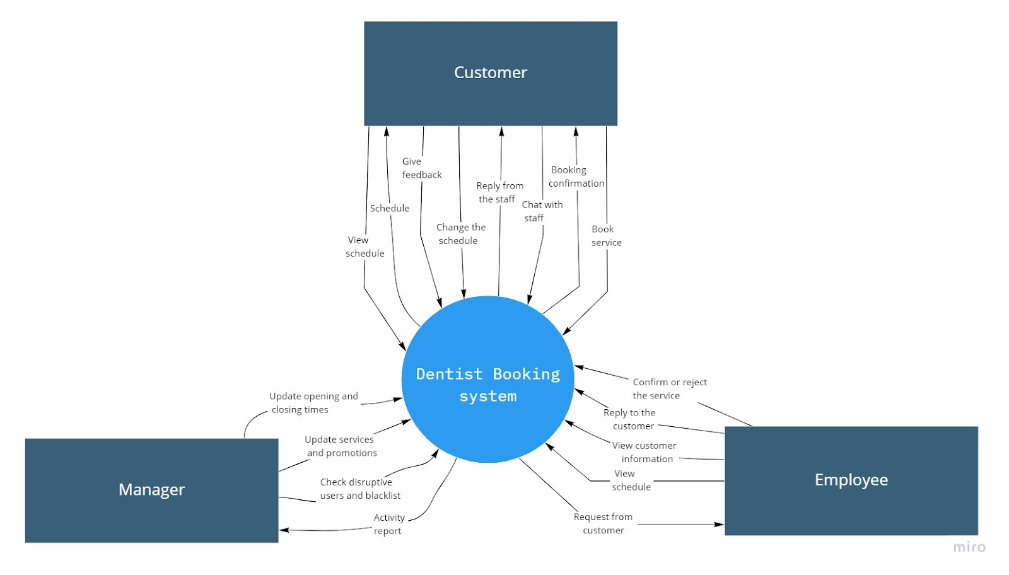The manager can update the status (closed/open) of the dental office, update services (add, remove, update), update promotions. Managers can check disruptive users and blacklists, view employee activity reports, and view customer reviews.

## 2. System Functions

#### a. Screen Flow

#### b. Screen Details

|  |  |  |  |
| --- | --- | --- | --- |
| **#** | **Feature** | **Screen** | **Description** |
| 1 | User information | User Profile | Show the information of the user when they log in. |
| 2 | Overview information | Home | Can view promotions and discounts on the side of the page. |
| 3 | Overview information | News | Show the latest news about service. |
| 4 | View service information | About Us | Show the information about the dentist. |
| 5 | Authentication | Login | Input username and password on system. |
| 6 | Authentication | Register | Users enter personal information to register for an account. |
| 7 | Authentication | Forget Password | User clicks the box “forgot password” then input new password and verify new password. |
| 8 | Service Management | Service | Manager can view and delete the service.  Customer can view the service. |
| 9 | Service Management | Add Service | Manager can add the new service to the list. |
| 10 | Service Management | Edit Service | Manager can edit the service info. |
| 11 | Service Management | Service Detail | View the detail of the service. |
| 12 | Booking Management | Booking | View booking schedule. |
| 13 | Booking Management | Create booking | Select add order on the left side of the menu to create a booking. |
| 14 | Booking Management | Edit booking | Customer can edit booking (cancel, change info booking) |
| 15 | Booking Management | History booking | Click on the “booking history tab” which shows all the booking information that the user has previously booked |
| 16 | Booking Management | List booking | Displays the list of bookings, you can click on specific bookings to view the booking description (appointment schedule, service description, ..). |
| 17 | Booking Management | Print booking info | Click the "print" button, it will write the information that the user has booked to the excel file and send it back to the user |
| 18 | Customer service | Chat box | Chat with staff. |
| 19 | Customer service | List Messenger | Reply the customer |
| 20 | Customer service | Feedback | Customer can write their feelings or comment what need to update about our service. |
| 21 | Customer service | Notification | Notice for customer about their booking. |
| 22 | Statistical | Manage Feedback | Manager can view the feedback from the customer. |
| 23 | Statistical | Manage history booking | Manager can view all the history booking of the customer to analysis. |
| 24 | Statistical | Manage user | Statistics on the number of registered customers. |
| 25 | Dentist Management | Manage dentist info | Add, update, edit or remove the info of dentist. |

#### c. User Authorization

|  |  |  |  |
| --- | --- | --- | --- |
| **Screen** | **C** | **E** | **M** |
| **Home Screen** | X | X | X |
| View Introduction and overview information | X | X | X |
| Search Information | X | X | X |
| **User Profile Screen** | X |  |  |
| View User information | X |  |  |
| Update User information | X |  |  |
| **News** | X |  |  |
| View News information | X |  |  |
| View details | X |  |  |
| Search News | X |  |  |
| **About Us** | X |  |  |
| View dentist information | X |  |  |
| View details | X |  |  |
| **Login Screen** | X | X | X |
| Login | X | X | X |
| **Register Screen** | X |  |  |
| Register | X |  |  |
| **Forget Password** | X |  |  |
| Password retrieval | X |  |  |
| **Service Screen** | X |  | X |
| View list service | X |  |  |
| Search service | X |  |  |
| Delete service |  |  | X |
| **Service Detail** | X |  |  |
| View service detail | X |  |  |
| **Add Service** |  |  | X |
| Add new service |  |  | X |
| **Edit Service** |  |  | X |
| Edit the service |  |  | X |
| **Booking** | X |  |  |
| View booking schedule | X |  |  |
| **Create Booking** | X |  |  |
| Add new booking | X |  |  |
| Add service | X |  |  |
| **Edit Booking** | X |  |  |
| Edit booking info | X |  |  |
| **History Booking** | X |  |  |
| View history booking info | X |  |  |
| Search history booking | X |  |  |
| **Notification Screen** | X |  |  |
| View Notification | X |  |  |
| Delete Notification | X |  |  |
| **List Booking** |  | X |  |
| Check booking status |  | X |  |
| Confirm booking |  | X |  |
| **Print booking info** |  | X |  |
| Export booking info |  | X |  |
| **Chat box** | X |  |  |
| Chat with staff | X |  |  |
| **List Messenger** |  | X |  |
| Reply customers |  | X |  |
| Block account |  | X |  |
| **Manage history booking** |  |  | X |
| List of statistics |  |  | X |
| **Manage user** |  |  | X |
| List of user register |  |  | X |
| Export Excel file |  |  | X |
| **Manage dentist** |  |  | X |
| Add dentist |  |  | X |
| View dentist |  |  | X |
| **Feedback Screen** | X |  |  |
| Write feedback | X |  |  |
| Update feedback | X |  |  |
| Delete feedback | X |  |  |
| **Manage feedback** |  | X |  |
| View Feedback |  | X |  |
| Search Feedback |  | X |  |
| Delete Feedback |  | X |  |

In which:

* Customer: The one will use the software to booking the service they want.
* Employee: The one will interact and fulfill orders for customers
* Manager: The one will manage and analysis the use of customer as well as the service of the system.

#### d. Non-Screen Functions

|  |  |  |  |
| --- | --- | --- | --- |
| **#** | **Feature** | **System Function** | **Description** |
| 1 | Email | Send mail OTP | Accessibility of the information and usability of the program is easy. With few clicks the user can reach the destination information. |
| 2 | Email | Send mail | When customer orders, system will automatic send email to their email. |

## 3. Common Requirements

* *Web server Apache Tomcat 9*
* *Web browser : Chrome Version*
* *Web password mã hóa SHA.*

# II. Functional Requirements

## 1. View service information

### a. View Introduction and overview information

*Function trigger: when the user enters the webs*

*Function description: This is the place for the user to overview the information about the dentist clinic.*

*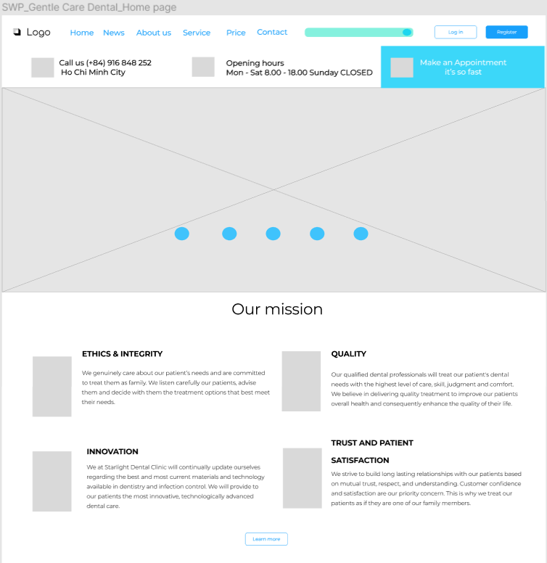Screen layout:*

*Function Details: Users can refer to the information available on the screen.*

### https://lh6.googleusercontent.com/tCi6ZreeiIl6YzDUmLQilz--oDWv_ko5GOhluOGIQixrEfTlhHUFPZkasWq1lgmLfhEqB7CX-cBbejD0W2re8y6OC_O-_APauPCBBCun54cShTs8X_oNx6LryWE9fX75cx4l3xs

### b. Search Information

*Function trigger: When user enters the keyword and click button search*

*Function description: This is the place for the user to search the information that they want.*

*Screen layout:*

*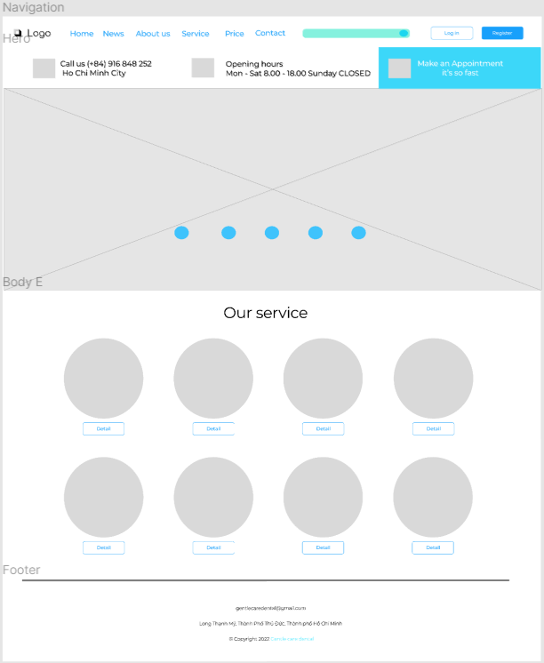Function Details: Users enter keywords in the search bar to search for services or news.*

### c. View News information

*Function trigger: When the user clicks the news button.*

*Function description: This is the place for the user to view the information about the dentist clinic.*

*Screen layout:*

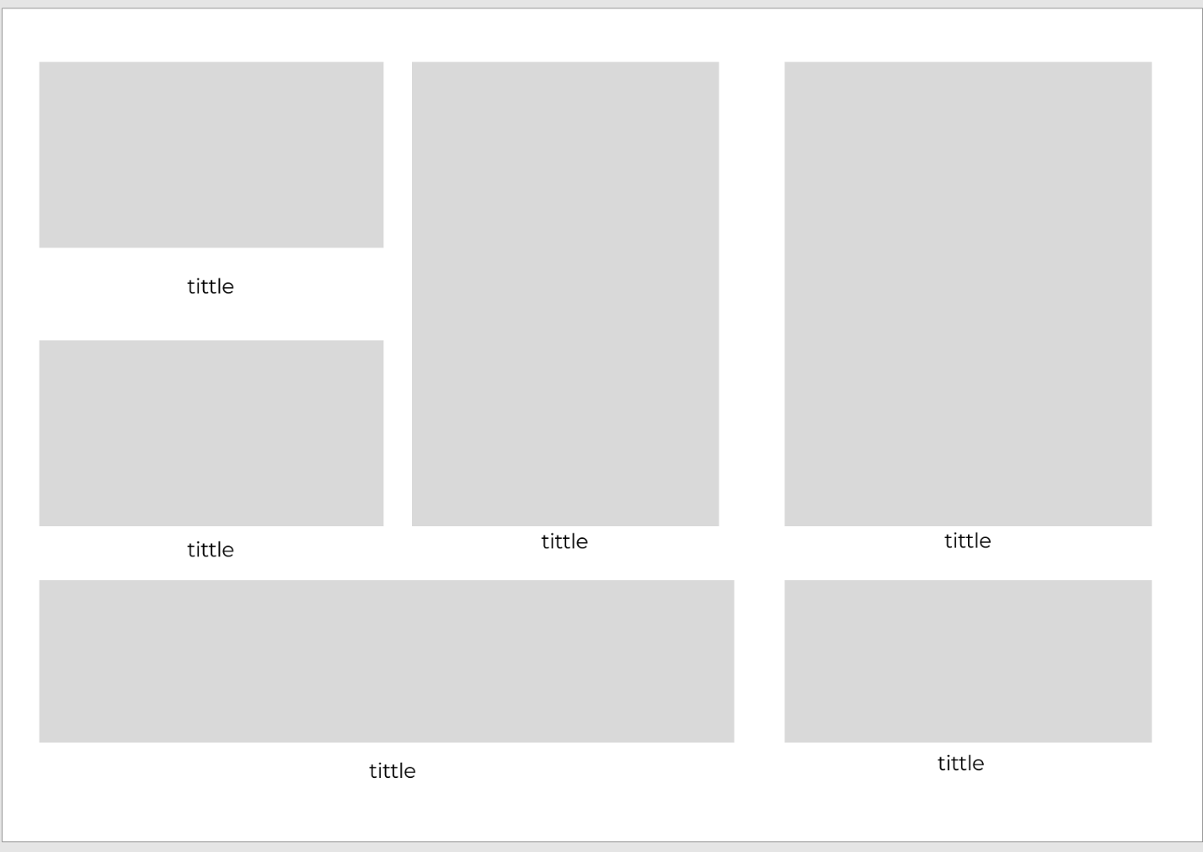

*Function Details: Users press the news button on the menu bar to view the latest news of the provider*

## 2. Authentication

## a. Register

*Function trigger: When the user clicks the register buttons.*

*Function description: This is the place for the user to sign up the information of the user login for convenience in booking service.*

*Screen layout:*

## https://lh5.googleusercontent.com/nhNEunWqpdfB0y8PvRcrap58WmoVAHaLE6MpMSp5Fro7QhmrnGZcyaHrZ5im8RApv_J5ubvEQI3imijo_N7JHAeL1qODotBF9Jw6yU0YVItRiNo5DhdMX_l0H1FDHXR-Js6w6cs

## *Function Details: Users input the personal information so that they can register an account to use web services.*

**b.Login**

*Function trigger: When the user clicks the login buttons on the home page.*

*Function description: This is the place for the user to login so that they can use the service of the web.*

*Screen layout:*

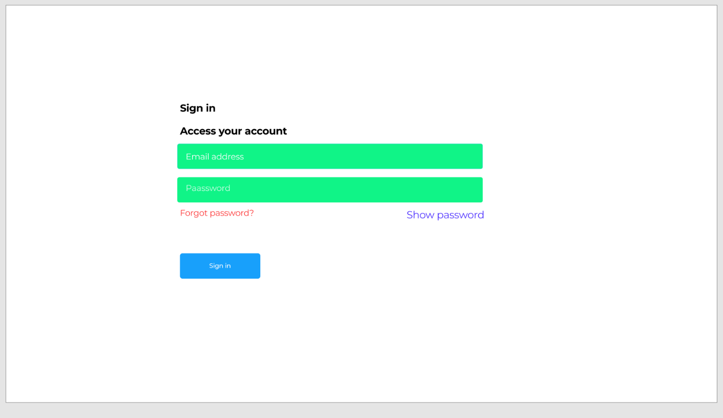

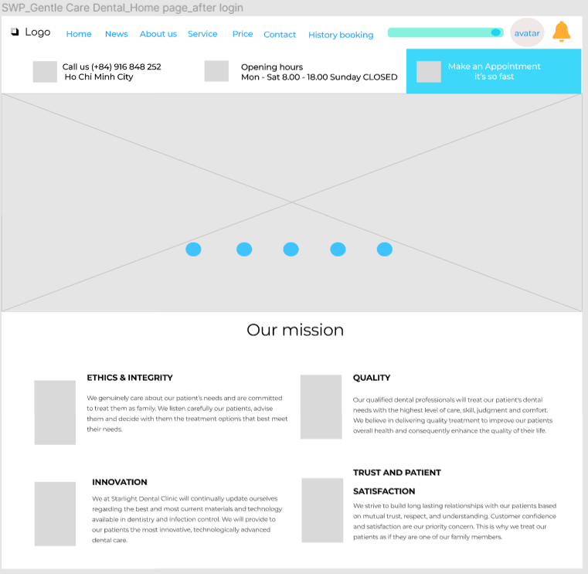

## *Function Details: Users can sign in to the website with their username and password so that they can use the service that the web provides.*

## c. Reset password

*Function trigger: When the user clicks the forget password button on the login page.*

*Function description: This is the place for the user to reset the password so that they can take back their account to log in back to the web.*

*Screen layout:*

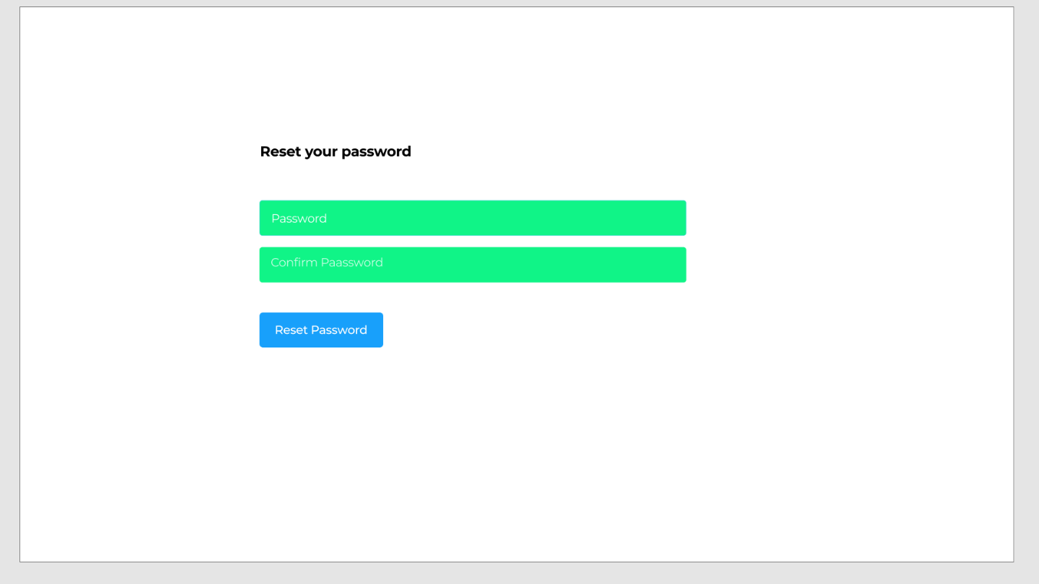*Function Details: Users can create a new password which you have to enter again the password to confirm so that the user can continue to use the account.*

## d. Notification

## *Function Details: Users click on the yellow bell icon to see the latest notification, can delete the notification by pressing the x button.*https://lh5.googleusercontent.com/yE_sg4QCXcrWr80SvYUDaTHDQ3MvBRkO_P9alvyiuqrAERjF8L32Q4mYFMX0uNbVxXvShP4Qx3a8zmDOsxEof7QZ0RNX_0HaFHsESWXNJEoT08B_kHuKJ5AE2FCO3qtIFqLRP38

## 3. Service Management

**a. Show service list**

*Function trigger: When the user enters click button services on the home page.*

*Function description: This is the place for the user to view all the services of the dentist clinic.*

*Screen layout:*

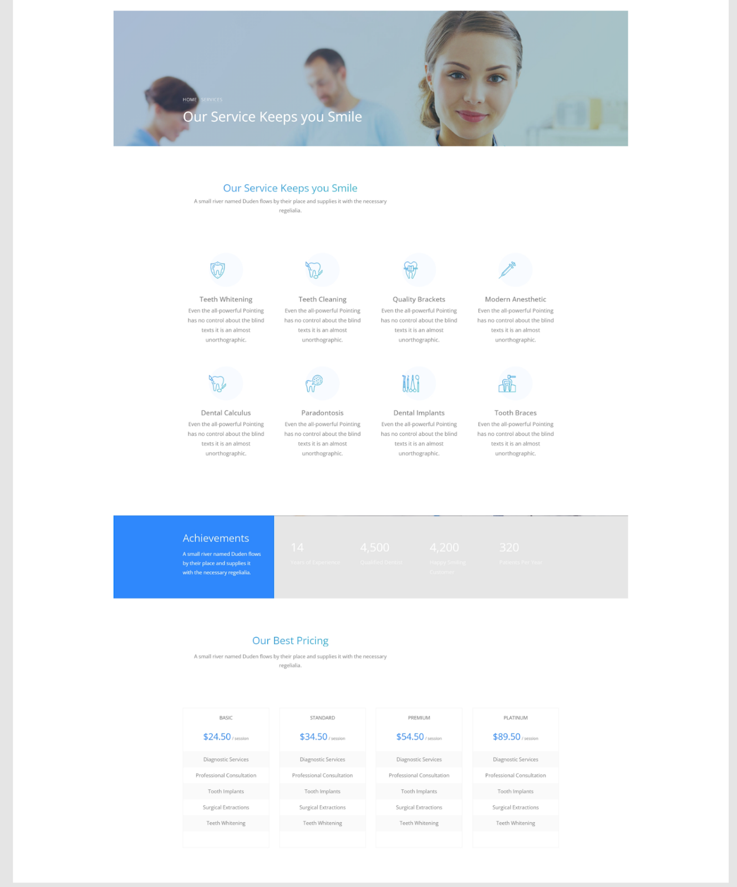

## *Function Details: Users can view all the services that the dentist clinic had and give them many choices to pick up and find out about it.*

**b. Show service detail**

*Function trigger: When the user clicks the services they chose.*

*Function description: This is the place for the user to view details about the services of the dentist clinic.*

*Screen layout:*

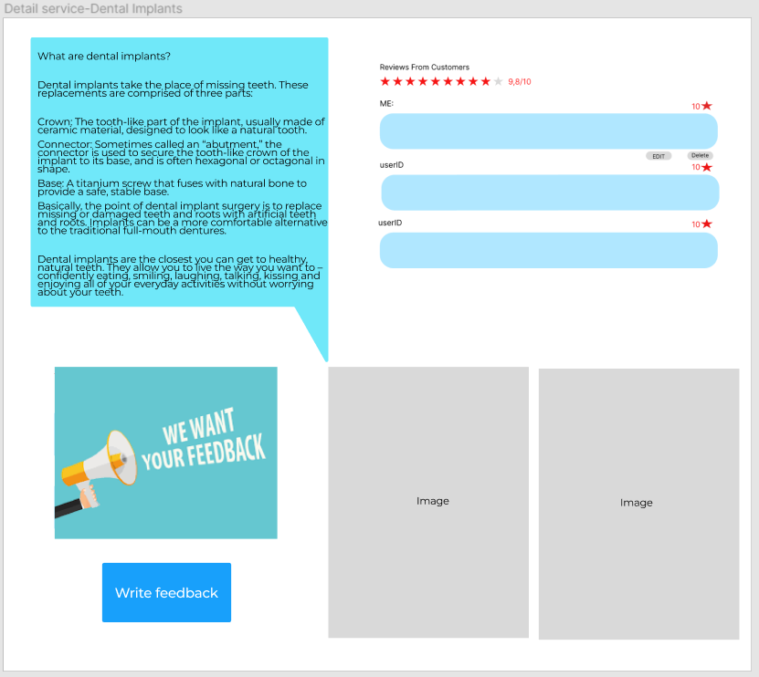

## *Function Details: Users can view in detail what the service is about and what services can do for the user and the many other info.*

**c. Show price list**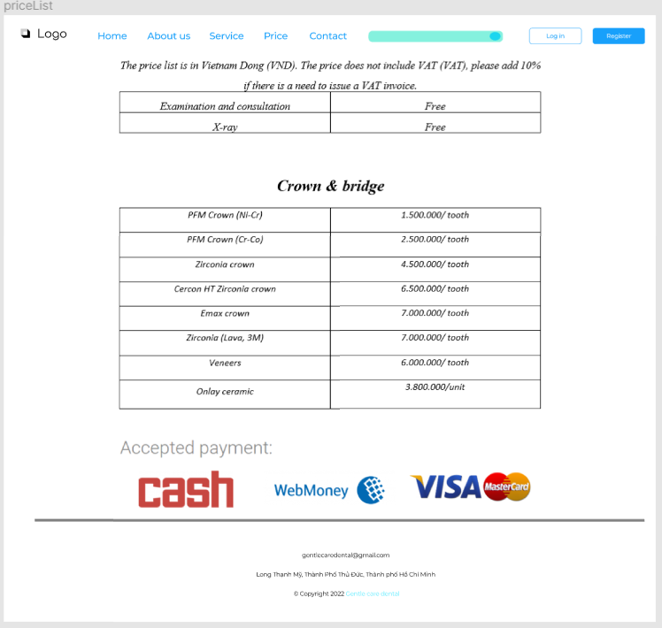

**c. Show service list for manage**

*Function Details: Display a list of available services*

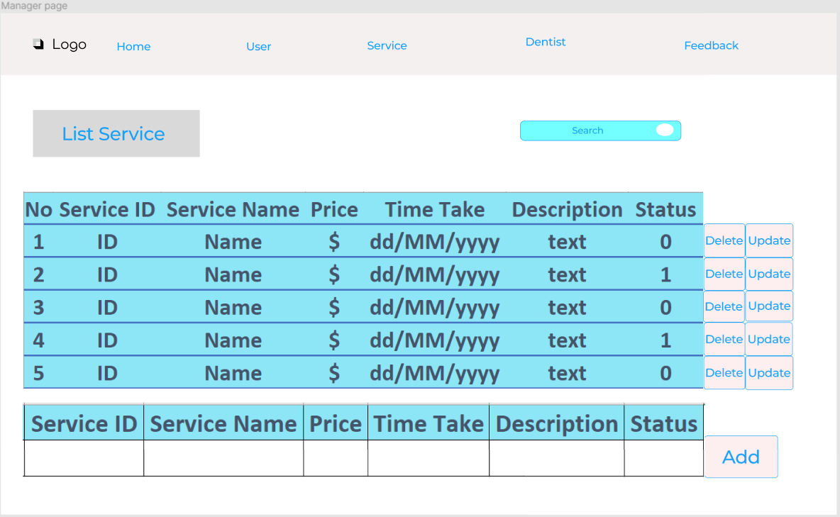

## d. Delete service

## *Function Details: Administrator can delete existing service.*

## e. Search service

## *Function Details: The administrator can search for the service in the list.*

## f. Edit service

## *Function Details: The administrator can edit the service's information.*

## g. Add new service

## *Function Details: Administrator can add new service.*

## 4. User information

**a. View User information**

*Function trigger: When the user clicks their avatar and then chooses the profile theu can view their own information.*

*Function description: This is the place for the user to view details about their information which they provide for the dentist clinic.*

*Screen layout:*

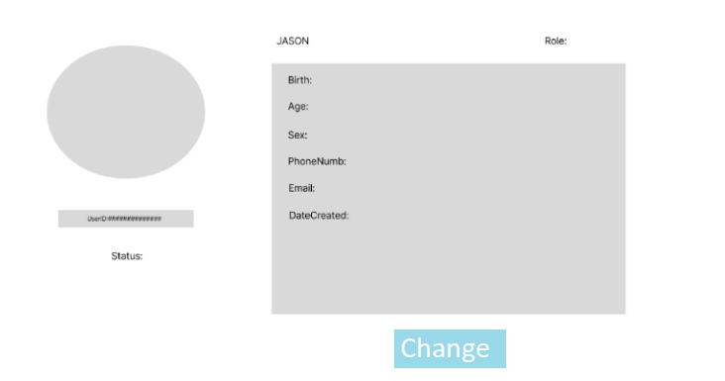

*Function Details: Users can view all the information which they provide for the website.*

**b. Update User information**

*Function trigger: When the user clicks their avatar and then chooses the profile then choose update buttons.*

*Function description: This is the place for the user to update their information which they provide for the dentist clinic.*

*Screen layout:*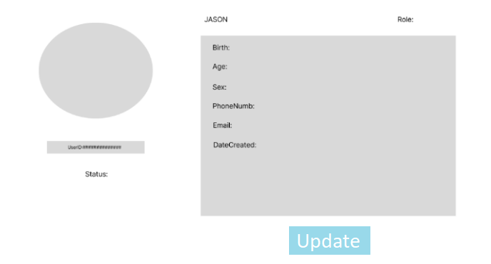

*Function Details: Users press the change profile button to change their information.*

**5.** Booking Management

**a. Check booking info**

*Function trigger: When the employee clicks the check buttons on the screen.*

*Function description: This is the place for the employee to view details about the booking  of the user.*

*Screen layout:*

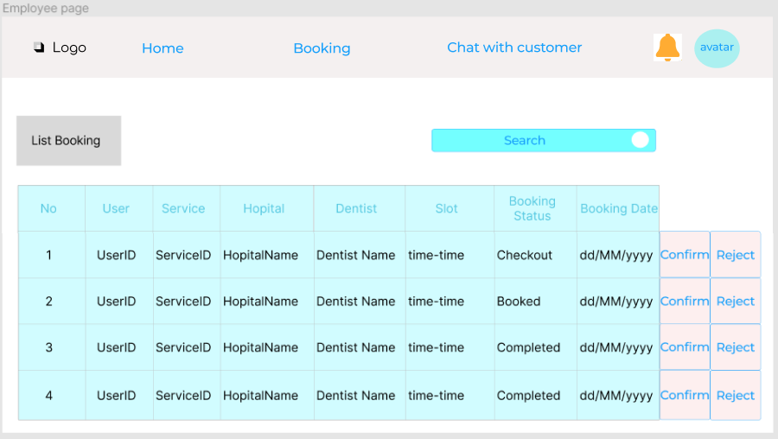

*Function Details: Employees can manipulate as well as make statistics based on these numbers.*

**b. View history booking info**

*Function trigger: When the user clicks the history buttons on the screen.*

*Function description: This is the place for the user to view the history of their booking.*

*Screen layout:*

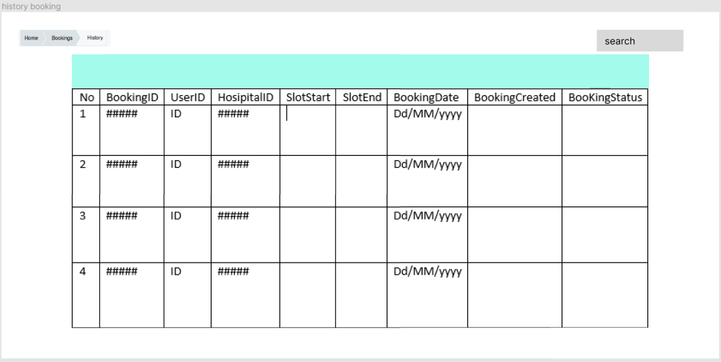

*Function Details: The user can view all the booking history which contain a lot of info about that day like what they did, when they did, where they did it.*

c **. Search history booking**

*Function trigger: When the user input into the search baron the screen.*

*Function description: This is the place for the user to search the history of their booking.*

*Screen layout:*



*Function Details: The user can search all the booking history and find the booking they want.*

**b. Create booking**

*Function trigger: When the user input into the table to book the service.*

*Function description: This is the place for the user to book the service they want.*

*Screen layout:*

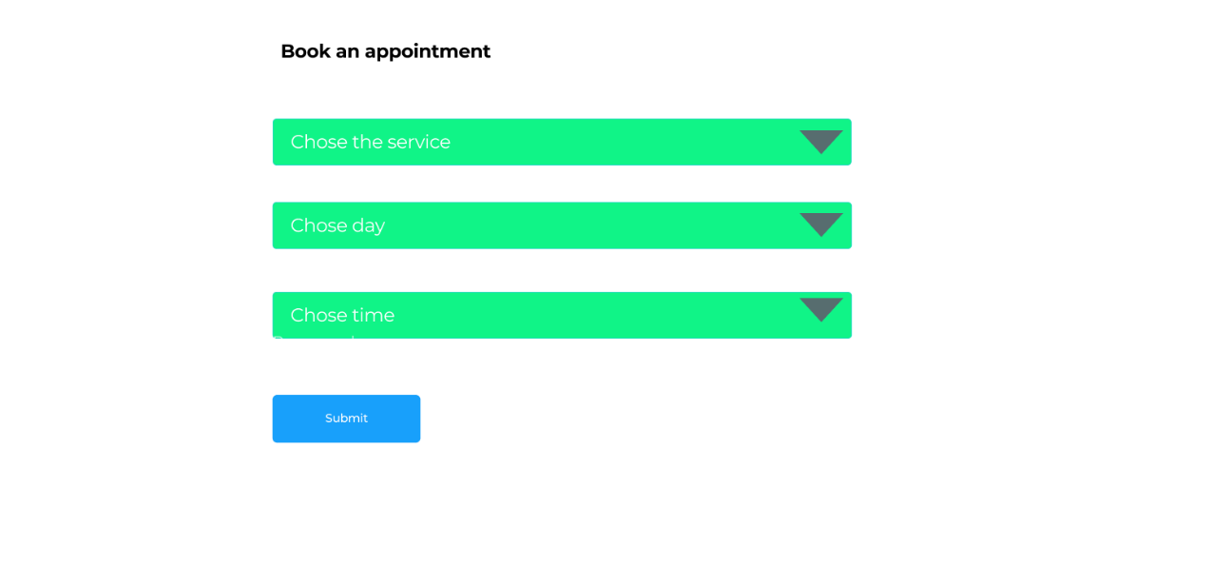

*Function Details: The user can book the service they want based on the day and time they chose.*

**6.** Customer service

**a. Chat with staff**

*Function trigger: When the user clicks the messenger icon on the right of the screen.*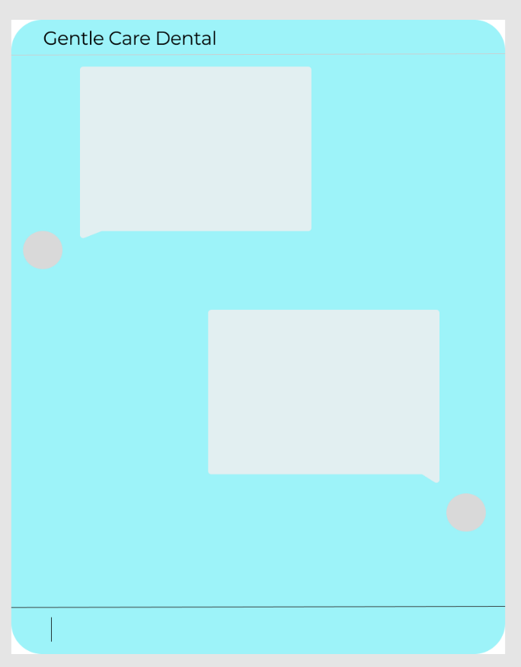

*Function description: This is the place for the user to chat with the staff to know more about the service.*

*Screen layout:*

*Function Details: Users can exchange and interact with staff through chat boxes, chat boxes appear on all pages of the website.And all the messenger .All messages will be saved to the database when the user selects the chat with staff function*

**b. Write/send feedback**

*Function trigger: When the user clicks the feedback buttons after booking the service.*

*Function description: This is the place for the user to write feedback about our service.*

*Screen layout:*

**

*Function Details: When the user clicks the write feedback button in the service detail page a form to write feedback appears. Users fill in their own opinions in the blanks, rate them through radio from 1 to 10 and click the send button to post them publicly.*

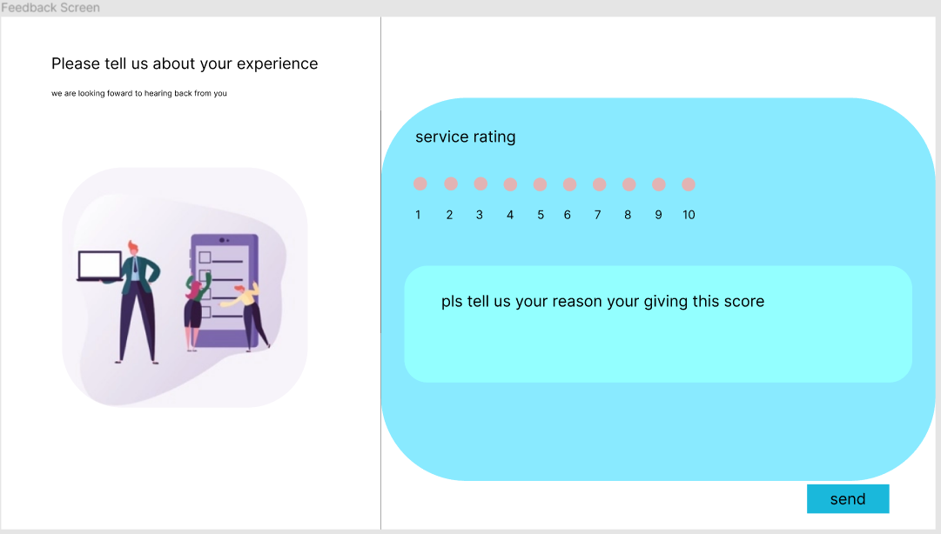

**c. Edit feedback**

*Function trigger: When the user clicks the edit button below their feedback.*

*Function description: This is the function for the user to edit the feedback they have written.*

*Screen layout:*

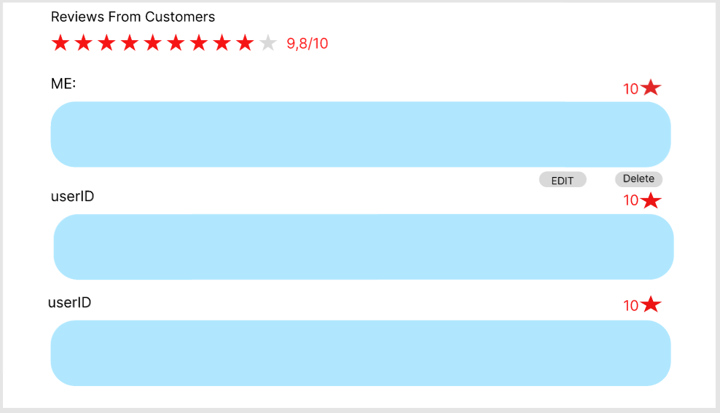

*Function Details: Users can view the ratings and comments of other users, and can change their own reviews.*

**d. Delete feedback**

*Function trigger: When the user clicks the delete button below their feedback.*

*Function description: This is the function for the user to delete the feedback they have written.*

*Screen layout:*



*Function Details: Users can view the ratings and comments of other users, and can delete their own reviews.*

**7. Dentist information**

aView Dentist

*Function trigger: When the user clicks the Dentist buttons on the home page.*

*Function description: This is the place for the user to see many dentist in this dentist clinic*

*Screen layout:*

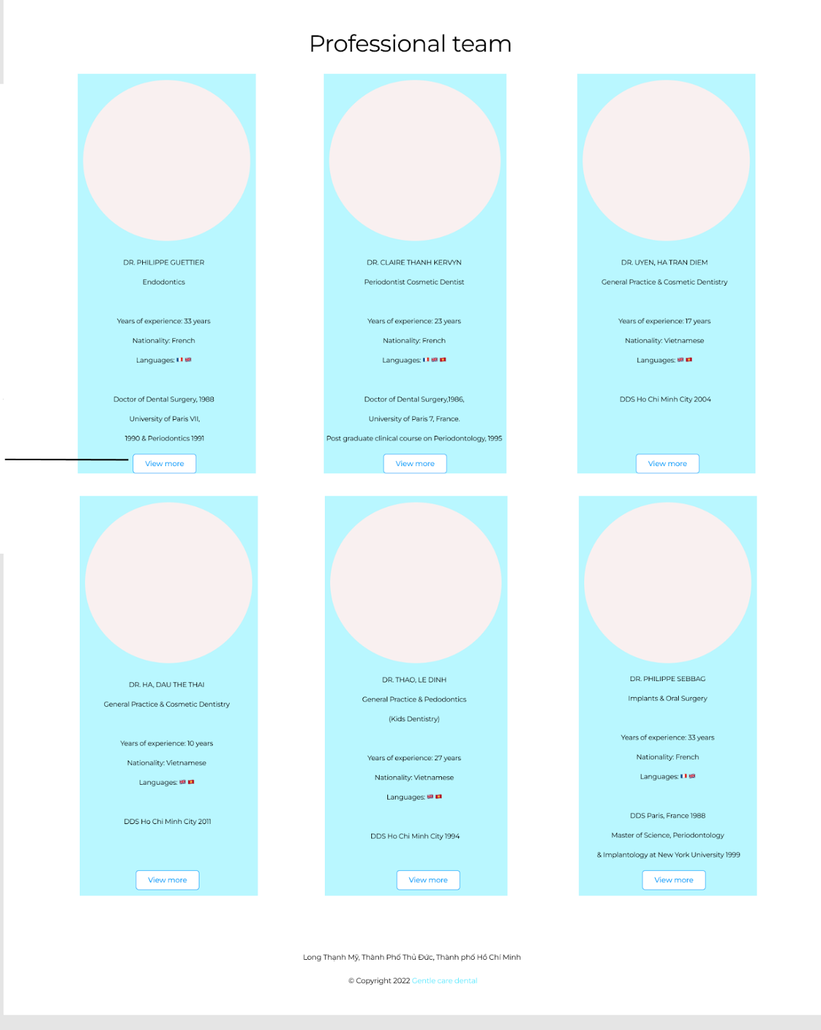

*Function Details: Users can overall the all the dentist about the experience of the dentist.*

bView Dentist Detail

*Function trigger: When the user clicks the view more of a dentist*

*Function description: This is the place for the user to view the dentist detail of the dentist*

*Screen layout:*

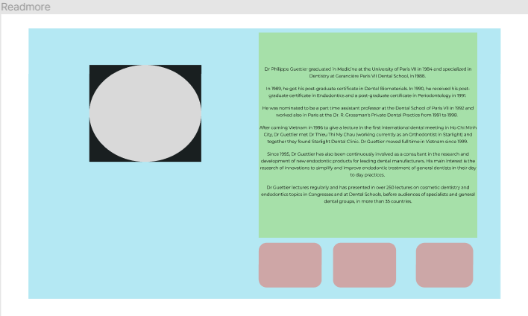

*Function Details: Users can view the dentist in detail what they have experienced in what service.*

**8.** Statistical

**a. List of user register**

*Function trigger: When the manager wants to analyse the user.*

*Function description: This is the place for the manager to analyse the user of the web.*

*Screen layout:***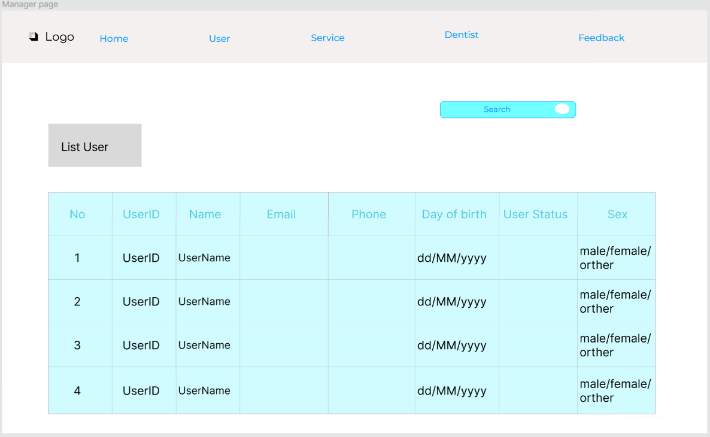**

*Function Details: Manager can analyse the user through the account they login.*

**9. Dentist Management**

**a. List of dentist**

*Function trigger: When the manager manages the info about the dentist.*

*Function description: This is the place for the managers to see all the dentist of the dentist clinic.*

*Screen layout:*

*Function Details: Manager can analyse the user through the account they login.*

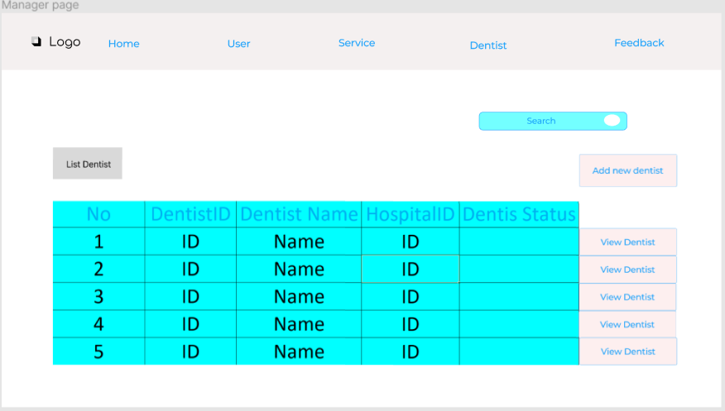

**b. View Dentist**

*Function trigger: When the manager manages the info about the dentist.*

*Function description: This is the place for the managers to see all the dentists of the dentist clinic.*

*Screen layout:*



**c. Add new dentist**

*Function trigger: When the manager wants to add a new dentist.*

*Function description: This is the place for the managers to add new dentists to the system of the dentist clinic.*

*Screen layout:*

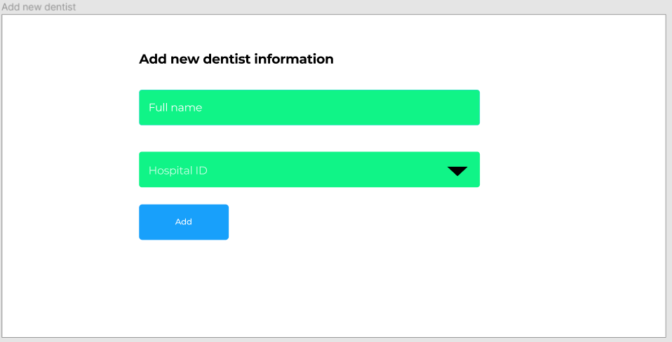

**10. Statistical**

**a. View feedback**

*Function trigger: When the manager clicks on the view Feedback buttons.*

*Function description: This is the place for the manager to view all the feedback of all the user about the service.*

*Screen layout:*

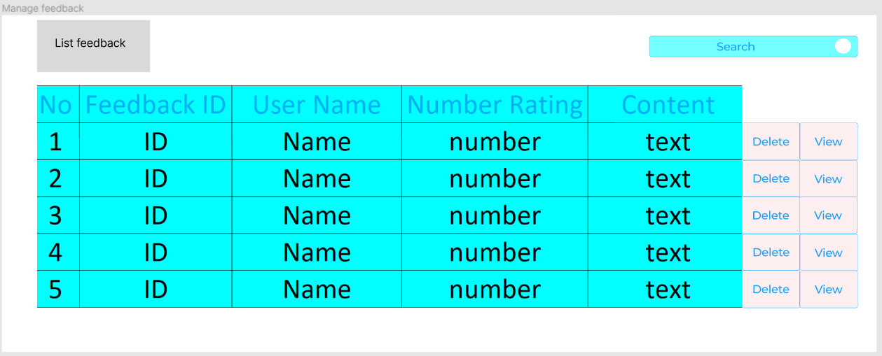

*Function Details: Manager can see a list of customer feedback. Click the view button to see detailed feedback content.*

**b. Search feedback**

*Function trigger: When the manager can input in the search bar.*

*Function description: This is the place for the manager to search for the feedback they want.*

*Screen layout:*



*Function Details: The manager enters userID in the search bar to find customer feedback.*

**c. Delete user feedback**

*Function trigger: When the manager clicks the delete button on the screen view feed.*

*Function description: This is the place for the manager to delete those who have a bad attitude.*

*Screen layout:*



*Function Details: Manager can click delete button to delete feedback which contains content that does not conform to the rules.*

11. **List Messenger**

**a. Reply customers**

*Function Details: Employees can chatting with customer*

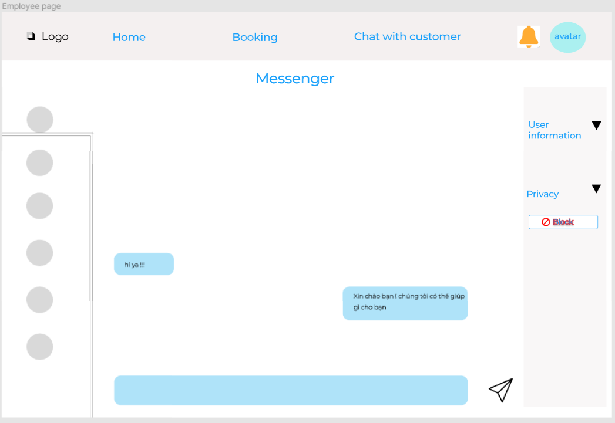

**b. Block account**



*Function Details: Employee can block messages from spam or offending accounts*